 | 
COUNCIL ASSESSMENT REPORT
NORTHERN REGIONAL PLANNING PANEL

PANEL REFERENCE & DA NUMBER | PPSNTH-133 – DA2021/53
PROPOSAL | Erection of a 4.95MW Solar Farm
ADDRESS | Lot 2 DP 773266  2910 Gwydir Highway, Moree
APPLICANT | Sundown Pastoral Co Pty Ltd
OWNER | Sundown Pastoral Co Pty Ltd and Namoi Cotton Ltd
DA LODGEMENT DATE | 28 October 2021
APPLICATION TYPE | Development Application
REGIONALLY SIGNIFICANT CRITERIA | Clause 5a Schedule 6 of the Planning Systems SEPP:  Private infrastructure and community facilities over $5 million  Development that has a capital investment value of more than $5 million for any of the following purposes—  (a) air transport facilities, electricity generating works, port facilities, rail infrastructure facilities, road infrastructure facilities, sewerage systems, telecommunications facilities, waste or resource management facilities, water supply systems, or wharf or boating facilities,  (b) affordable housing, child care centres, community facilities, correctional centres, educational establishments, group homes, health services facilities or places of public worship.
CIV | $12,000,000 (excluding GST)
CLAUSE 4.6 REQUESTS | Not applicable
KEY SEPP/LEP | - State Environmental Planning Policy (Biodiversity and Conservation) 2021  - Chapter 4 – Koala Habitat Protection 2020  - State Environmental Planning Policy (Planning Systems) 2021  - Part 2.3 Regionally Significant Development  - State Environmental Planning Policy (Resilience and Hazards) 2021  - Chapter 4 – Remediation of Land  - State Environmental Planning Policy (Primary Production) 2021;  - State Environmental Planning Policy (Transport and Infrastructure) 2021  - Chapter 2 – Infrastructure  - Moree Plains Local Environmental Plan 2011
TOTAL & UNIQUE SUBMISSIONS KEY ISSUES IN SUBMISSIONS | Nil submissions were received.
DOCUMENTS SUBMITTED FOR CONSIDERATION | The following documentation was submitted for consideration and relied on for determination, provided under separate cover:  ATTACHMENT:  - Cost Estimate Report  - Statement of Environmental Effects (SoEE) prepared by SMK Consultants (ref: 21-367 and dated September 2021)  The following documents submitted for consideration are provided within the SoEE dated September 2021:  - Appendix 1 – Site Plans [superseded by below]  - Appendix 2 – Draft Bushfire Management Plan  - Appendix 3 – SEPP 55 – Preliminary Site Investigation  - Appendix 4 – CASA Correspondence  - Appendix 5 – Flood Work Approval  - Appendix 6 – AHIMS Result  - Appendix 7– Biodiversity Act 2016 – Test of Significance  - Appendix 8 – Environmental Protection and Biodiversity Conservation Act 1999 – Assessment of Significance  - Addendum prepared by SMK Consultants (ref: 21-367 and dated 6 January 2022)  - Addendum prepared by SMK Consultants (ref: 21-367 and dated 21 January 2022)  - Addendum prepared by SMK Consultants (ref: 21-367 and dated 8 February 2022)  The following documents submitted for consideration are provided within the Addendum letter dated 8 February 2022:  - Appendix 1 – Plans prepared by Kinelli Pty Ltd (ref: S092021-4, sheets 1 – 4, rev: E and dated 17/01/2022)  - Proposed Wathagar Solar Farm Access via Keytah Property Entrance prepared by SMK Consultants (ref: 21-367 and dated 2 May 2022).  The following attachments are also provided to this report:  - DCP Compliance Table  - Conditions of Consent
SPECIAL INFRASTRUCTURE CONTRIBUTIONS (S7.24) | No
RECOMMENDATION | Approval
DRAFT CONDITIONS TO APPLICANT | No
SCHEDULED MEETING DATE | 19 July 2022
PLAN VERSION | 17 January 2022 Revision E
PREPARED BY | Erin Daniel | Principal Planner – Perception Planning
DATE OF REPORT | 11 July 2022

EXECUTIVE SUMMARY
The development proposal incorporates the private construction of a solar farm to initially supply power to the cotton gin. Subsequent approval to connect to the Essential Energy grid infrastructure will occur with approval from Essential Energy under separate process. This proposal includes the construction of infrastructure to allow subsequent connection. The maximum transfer capacity to the grid will be 4395 MW AC. The proposal was amended on 8 February 2022 to alter and reduce the components of the development. The proposal for consideration now includes:

- 48 PEG EW structures (6 structures in each east/west row and 8 rows running north/south). Each structure is comprised of 14 PV modules east/west by 28 PV modules north/south. The structure dimensions are 30.201 m (east/west) x 29.988 m (north/south). The PV module will be sourced from a Global Tier 1 supplier.
- 1 combined inverter/transformer stations.
- 4 battery storage containers with a combined storage capacity of 11 MWh.
- Cabling and switchgear.
- 1.8m surrounding chain link fence with 2 x 6m double leaf gate.
The PV modules will be mounted on piers with a minimum height above ground level of 750mm and a maximum height of 1047mm. The amendment to the plan has resulted in a reduction of subject area from 8.6ha to 6.088ha.

The proposed development is located at Lot 2 in Deposited Plan 773266, commonly identified as 2910 Gwydir Highway, Wathagar, NSW 2400, known as ‘the site’ for the purpose of this report. The ‘development area’ is a trapezoidal portion of the site located slightly west of the centre on the southern boundary. The site is relatively rectangular in shape with an area measuring approximately 168ha; the development area measures approximately 6.088 ha. The site is zoned RU1 – Primary Production, with land adjoining the site in all directions also zoned for this purpose.

The site is flat in topography and clear of vegetation, with a single water course that traverses through the south-west portion of the site. The site has historically been used for agricultural cultivation of cotton. The land surrounding the site has been cultivated for agricultural purposes. A cotton gin and ancillary sheds are located centrally within the subject site. Existing Essential Energy infrastructure is located on the subject site including the 22kV distribution power lines and the Wathagar Zone substation (WTR9B3).

State Environmental Planning Policy (Planning Systems) 2021 (‘Systems SEPP’) applies to the proposal as it identifies if development is regionally significant development. In this case, pursuant to Clause 2.19 of Systems SEPP, the proposal is a regionally significant development as it satisfies the criteria in Clause 5(a) of Schedule 7 of the SRD SEPP as the proposal is development for electricity generating works with a CIV over $5 million. The purpose of the State Environmental Planning Policy (Transport and Infrastructure) 2021 (‘T&I SEPP’) is to facilitate the effective delivery of infrastructure across the state and identifying matters to be considered in the assessment of developments adjacent to specific types of development.
Pursuant to Clause 2.36(1)(b) development for the purpose for electricity generating works may be carried out by any person with consent on land in a prescribed rural, industrial, or special use zone. The RU1 Zone is identified as prescribed zones under Clause 2.35 – Definitions. Accordingly, the development is permissible with consent under Clause 2.36(1)(b). The proposal is also permissible with consent in the RU1 zone and is consistent with these zone objectives detailed under the Moree Plains Local Environmental Plan 2011 (MLEP) for the following reasons:
- The development proposal does not result in the fragmentation of agricultural land nor result in land use conflict between adjoining zones;
- The development proposal encourages sustainable energy production and diversifies the economic and commercial enterprises and employment opportunities within the municipality; and
- The rural character of the locality is not significantly compromised because of the development.
Accordingly, the subject site is deemed suitable for the proposed development. There were concurrence and integrated requirements from agencies for the proposal, accordingly the application was referred to Essential Energy, Natural Resource Access Regulators (NRAR), Transport for NSW (RfNSW) and the Rural Fire Service (RFS).
NRAR, EE and the RFS all returned referrals with conditions of approval, as detailed in the consent. TfNSW responded in December 2021 requesting additional information from the applicant. In response, the Applicant revised the site access to remove access via the Gwydir Highway. A revised referral was provided to TfNSW advising of this. At the time of writing this Report, no response from TfNSW had been received. It is understood a response is imminent and will be provided to the Panel prior to determination. Given the removal of access to the Classified Road, it is anticipated TfNSW will not raise any concerns.
A briefing was held with the Panel on 16 February 2022 where key issues were discussed including:

- Visual Impact – site is adjoined by existing 3m high levee, significantly limiting the visual impact from highway traffic. No landscaping proposed. Glint and Glare Assessment Concluded no impacts on traffic safety.
- Stormwater – existing on-site stormwater management to be utilised.
- Traffic and access – referral to TfNSW with additional information request in relation to the level of construction for safe traffic movement into / from the site, particularly during construction.
- Flooding – site enclosed by approved levee. NRAR requested to provide confirmation on any necessary approvals due to location of existing (gated) watercourse on the site.
- Access to the site is to be addressed in the assessment report.

In response to the key issues raised in the briefing the following is made:

- Further site inspection was undertaken to determine whether Council are satisfied that the change to the rural landscape is acceptable without additional mitigation measures. Observation revealed that the visual impacts from the proposed solar farm would not be significant when viewed from the Gwydir Highway. A photograph provided in this Report is provided from the highway at the height of an SUV. The proposed solar farm would be predominately screened by the flood levee bank which is some 3m above natural ground level. Final observation is that highway users in light vehicles would not be able to view the solar farm due to the levee bank while partial views would be possible from trucks and buses.
- Council’s Engineering Officer reviewed the submitted stormwater concept plan and considered that there were no objections. The letter submitted by SMK on 6th January 2022 (Ref:21-367) in relation to the proposed stormwater management for the proposed 4.95 MW Solar Farm was accepted.
- The primary access to the development has been revised, resulting in access from the west via main Keytah Property access from the Goonal Road and not from the Gwydir Highway. The ‘informal’ gravel access track located on-site will not be utilised by the personnel and contractors associated with construction and operation of the solar farm. An owner’s consent form for Sundown Pastoral Pty was lodged with the DA, noting that the land proposed for site access is also in this ownership, thus covers the proposed amendment. These details were provided to TfNSW for consideration, however at the time of writing this report, no response was received. Given the access no longer is proposed via the Gwydir Highway, all construction traffic including all heavy vehicle traffic would access the site from a local road, meaning that the proposal has minimal impact on the state road. It is understood a response is imminent and will be provided to the Panel prior to determination. Given the removal of access to the Classified Road, it is anticipated TfNSW will not raise any concerns.
The internal access road was considered by Council Engineers to determine whether any widening is required to allow the safe movement of vehicles against the current cotton gin operations on site. Council’s Engineers are satisfied for the vehicle swept paths analysis to be a DA condition tied to the Driveway Access Application. They are of the view that there is sufficient space for road trains etc and the detailed plans will provide an accurate basis for design.
- NRAR referral was provided, noting a controlled activity approval is required prior to the issue of a construction certificate. This has been placed as a condition of consent.
- Refer to point (3) above.
Following consideration of the matters for consideration under Section 4.15(1) of the EP&A Act, the provisions of the relevant State environmental planning policies, the MLEP 2011 and the MDCP, the proposal is supported. Following a detailed assessment of the proposal, pursuant to Section 4.16(1)(a) of the EP&A Act, DA2021/53 is recommended for approval subject to the conditions contained at Attachment 8 of this report.
- THE SITE AND LOCALITY

  - The Site
The proposed development is located at Lot 2 in Deposited Plan 773266, commonly identified as 2910 Gwydir Highway, Wathagar, NSW 2400 (FIGURE 1), known as ‘the site’ for the purpose of this report. The ‘development area’ is a trapezoidal portion of the site located slightly west of the centre on the southern boundary, shown in FIGURE 2. The site is relatively rectangular in shape with an area measuring approximately 168ha; the development area measures approximately 6.088 ha.

The site is flat in topography and clear of vegetation, with a single water course that traverses through the south-west portion of the site. The site has historically been used for agricultural cultivation of cotton. The land surrounding the site has been cultivated for agricultural purposes. A cotton gin and ancillary sheds are located centrally within the subject site. Existing Essential Energy infrastructure is located on the subject site including the 22kV distribution power lines and the Wathagar Zone substation (WTR9B3).

Existing primary access to the site is achieved via Gwydir Highway, with the vehicular access crossover located in the south-west corner. Gwydir Highway bounds the site to the south and is a classified state road under the maintenance of Transport for NSW (TfNSW). The township of Moree is located approximately 30km to the northeast of the site.
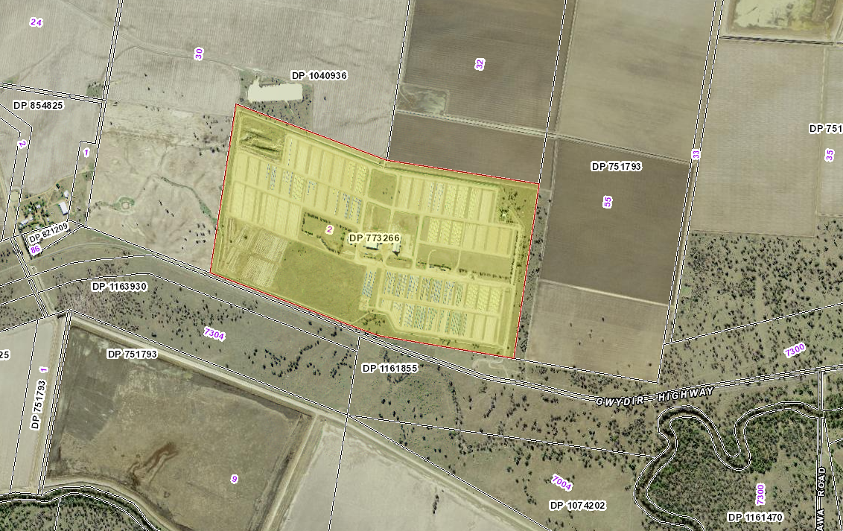
Figure 1: Site within the surrounding locality (SixMaps, 2021)
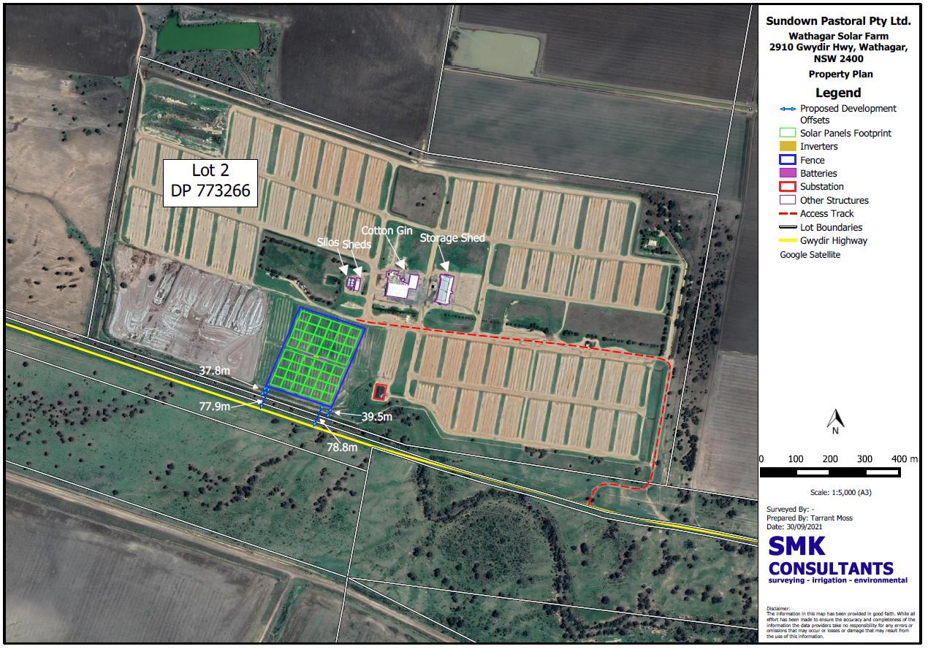
Figure 2: Subject area within site measuring approximately 8.6 ha on southern boundary (SKM, 2021)

  - The Locality
The site is zoned RU1 – Primary Production under the Moree Plains Local Environmental Plan 2011 (MLEP). The land surrounding the subject site is also zoned RU1. Aerial imagery suggests the subject site and the surrounding land is farmed in some capacity. No other known solar farms are present in the locality.
- THE PROPOSAL AND BACKGROUND

  - The Proposal
The development proposal incorporates the private construction of a solar farm to initially supply power to the cotton gin. Subsequent approval to connect to the Essential Energy grid infrastructure will occur with approval from Essential Energy under separate process. This proposal includes the construction of infrastructure to allow subsequent connection. The maximum transfer capacity to the grid will be 4395 MW AC.

The proposal was updated on 8 February 2022 to alter the components of the development. The proposal includes (see TABLE 1 below):

- 48 PEG EW structures (6 structures in each east/west row and 8 rows running north/south). Each structure is comprised of 14 PV modules east/west by 28 PV modules north/south. The structure dimensions are 30.201 m (east/west) x 29.988 m (north/south). The PV module will be sourced from a Global Tier 1 supplier.
- 1 combined inverter/transformer stations.
- 4 battery storage containers with a combined storage capacity of 11 MWh.
- Cabling and switchgear.
- 1.8m surrounding chain link fence with 2 x 6m double leaf gate.
The PV modules will be mounted on piers with a minimum height above ground level of 750mm and a maximum height of 1047mm.

The amendment to the plan has resulted in a reduction of subject area from 8.6ha to 6.088ha. Amended architectural plans are contained in Attachment 4.

The ‘development area’ is a trapezoidal portion of the site located slightly west of the centre on the southern boundary. The development achieves a front boundary offset to the southeast corner of the subject area measuring 39.5m and to the southwest corner measuring 37.8m. The offset from Gwydir Highway is in excess of 75m.

On 2 May 2022, an amendment to the site access was made by the Applicant, via Goonal Road to the west of the site. The access route traverses two properties:
- 2540 Watercourse Road, owned by Sundown Pastoral Co Pty Ltd; and
- 833 Goonal Road, owned by ACN 000 029 747 Pty Ltd

The proposed site access is the main Keytah Property access from the Goonal Road and is the formal access to the Keytah office and homestead facilities. An owner’s consent form for Sundown Pastoral Pty was lodged with the DA, noting that the land proposed for site access is also in this ownership, thus covers the proposed amendment. No access via Gwydir Highway is proposed. Refer to Attachment 6 for further details.

Construction is anticipated to occur over 10-12 weeks (3 months). Construction hours proposed are:

Mon – Fri 7am to 6pm
Sat 8am to 1pm

No works on Sunday or Public Holidays

Operation of the facility will be 24 hours a day, 7 days a week with no permanent staff. Maintenance will be taken on a daily or as need basis. The proposed development is shown in Figure 2 and contained within Attachment 4 of this Report.
Table 1: Development Data
Control | Proposal
Site area | 6.09 ha
GFA | NA
FSR (retail/residential) | NA
Clause 4.6 Requests | No
No of apartments | NA
Max Height | Trackers at full tilt measure 1.047m above NGL. Clearance of PV panel is 750mm above NGL.
Landscaped area | No formal landscaping provided.
Car Parking spaces | No formal parking spaces provided.
Setbacks | Front boundary varies between 39.5m and 37.8m.  Setback from Gwydir Highway varies between 77.9m and 78.8m

  - Background

A pre-lodgement meeting was not requested prior to the lodgement of the applicant.

The development application was lodged on 28 October 2021. A chronology of the development application since lodgement is outlined in TABLE 2 below including the Panel’s involvement (briefings, deferrals etc) with the application:

Table 2: Chronology of the DA
Date | Event
28 October 2021 | DA lodged
11 November 2021 | Exhibition of the application
4 November 2021 | DA referred to external agencies
20 December 2021 | Request for Information (RFI) from Council to Applicant.
6 January 2022 | Detailed RFI response provided from Applicant to Council.
21 January 2022 | Applicant response to TfNSW request provided.
8 February 2022 | Development amended to reduce the size and scale of the development.
16 February 2022 | Panel briefing held.
2 May 2022 | Applicant amendment made to the site and development area access, via Goonal Road.

  - Site History

The site has been historically used for rural and agricultural purposes. In the 1980’s an intensification of use occurred with the arrival of the cotton industry. This saw the site and adjacent lands utilised for cotton growing and processing with the construction of a cotton gin. These land uses continue to exist.

Council maintains record of one previous DA for the subject lot. This being DA99/10331 for a cotton storage shed, approved on 23 December 1999.

There are no concurrent applications currently being considered
- STATUTORY CONSIDERATIONS
When determining a development application, the consent authority must take into consideration the matters outlined in Section 4.15(1) of the Environmental Planning and Assessment Act 1979 (‘EP&A Act’). These matters as are of relevance to the development application include the following:

- the provisions of any environmental planning instrument, proposed instrument, development control plan, planning agreement and the regulations
- the likely impacts of that development, including environmental impacts on both the natural and built environments, and social and economic impacts in the locality,
- the suitability of the site for the development,
- any submissions made in accordance with this Act or the regulations,
- the public interest.

These matters are further considered below.

It is noted that the proposal is considered to be (which are considered further in this report):

- Integrated Development (s4.46) – Referral to NRAR is required under the Water Management Act 2000.
- Advice – Referral to the NSW Rural Fire Service is required under Section 4.14 of the Environmental Planning and Assessment Act 1979.
- Designated Development (s4.10) – Development proposal is for 4.95MW solar farm. This does not constitute designated development as described under Clause 18 of Schedule 3 of the EP&A Regulation 2000.
- Requiring concurrence/referral (s4.13) – Yes, Electricity Supply Authority
- Crown DA (s4.33) – No, development application does not pertain to a Crown DA or Crown Land.
  - Section 4.15(1)(a)(i) - Provisions of Environmental Planning Instruments
The following Environmental Planning Instruments are relevant to this application
- State Environmental Planning Policy (Biodiversity and Conservation) 2021
  - Chapter 4 – Koala Habitat Protection 2020
- State Environmental Planning Policy (Planning Systems) 2021
  - Part 2.3 Regionally Significant Development
- State Environmental Planning Policy (Resilience and Hazards) 2021
  - Chapter 4 – Remediation of Land
- State Environmental Planning Policy (Primary Production) 2021;
- State Environmental Planning Policy (Transport and Infrastructure) 2021
  - Chapter 2 – Infrastructure
- Moree Plains Local Environmental Plan 2011.
A summary of the key matters for consideration arising from these State Environmental Planning Policies are outlined in TABLE 3 and considered in more detail below.

Table 3: Summary of Applicable State Environmental Planning Policies
EPI | Matters for Consideration | Comply (Y/N)
Planning Systems SEPP | - Clause 2.19(1) declares the proposal as regionally significant development pursuant to Clause 5 of Schedule 6. | Y
Resilience and Hazards SEPP  Chapter 4 | - Clause 4.6 - Contamination and remediation has been considered in the Statement of Environmental Effects and the proposal is satisfactory. | Y
Transport and Infrastructure SEPP  Chapter 2 | - Clause 2.36 Development permissible with consent – The proposed development is permissible with consent under Clause 34(1)(b).  - Clause 2.48 (Determination of development applications—other development) – electricity transmission - the proposal is satisfactory subject to conditions.  - Clause 2.76 – Development adjacent to pipeline corridors - NA  - Clause 2.97 – Development adjacent to rail corridors – NA  - Clause 2.118 Development with frontage to classified road – Gwydir Highway is a classified road. As such referral to TfNSW is required.  - Clause 2.119 Impact of road noise or vibration on non-road development - NA  - Clause 2.121 - Traffic-generating development – The development is not classified as traffic generating development. | Y
Biodiversity and Conservation SEPP  Chapter 3 | - Clause 7 declares land to which this policy applies  - Clause 8 – Is the land potential koala habitat? – Site is cleared of vegetation | Y
Primary Production SEPP | Not applicable | NA
State Environmental Planning Policy (Planning Systems) 2021
State Environmental Planning Policy (Planning Systems) 2021 (‘Systems SEPP’) applies to the proposal as it identifies if development is regionally significant development. In this case, pursuant to Clause 2.19 of Systems SEPP, the proposal is a regionally significant development as it satisfies the criteria in Clause 5(a) of Schedule 6 as the proposal is development for electricity generating works with a CIV over $5 million. Accordingly, the Northern Regional Planning Panel is the consent authority for the application. The proposal is consistent with this Policy.

State Environmental Planning Policy (Resilience and Hazards) 2021
Chapter 4 – Remediation of Land
The provisions of Chapter 4 of the State Environmental Planning Policy (Resilience and Hazards) 2021 (‘R&H SEPP’) have been considered in the assessment of the development application. Clause 4.6(1) of the R&H SEPP requires consent authorities to consider whether the land is contaminated, and if the land is contaminated, it is satisfied that the land is suitable in its contaminated state (or will be suitable, after remediation) for the purpose for which the development is proposed to be carried out.
To consider the above, a review of the EPA register of contaminated land was conducted. The land was not identified as being substantially contaminated. The site has historically been used for agricultural purposes, as such potential sources of contamination by way of herbicides and pesticides is likely. However, despite this risk, the development proposal is for a non-residential use with limited ongoing exposure to the land through maintenance. It is not considered that a Preliminary Site Investigation is warranted, nor remediation is necessary. It is considered that the land is fit for the intended purpose of a solar farm.
The proposal is consistent with Chapter 4 of the R&H SEPP.

State Environmental Planning Policy (Transport and Infrastructure) 2021
Chapter 2 - Infrastructure
The purpose of the State Environmental Planning Policy (Transport and Infrastructure) 2021 (‘T&ISEPP’) is to facilitate the effective delivery of infrastructure across the state and identifying matters to be considered in the assessment of developments adjacent to particular types of development.
The proposed development is for a 5MW solar electricity generating farm with future connection to the Country Energy Substation. Pursuant to Clause 2.36(1)(b) development for the purpose for electricity generating works may be carried out by any person with consent on land in a prescribed rural, industrial, or special use zone. The RU1 Zone is identified as a prescribed zone under Clause 2.35 – Definitions. Accordingly, the development is permissible with consent under Clause 2.36(1)(b).
Pursuant to Clause 2.48(1)(b)(iii) referral to the electricity supply authority is triggered. Referral to the electricity supply authority was completed 30 November 2021. The response from the electricity supply authority concluded:
Essential Energy has no comments to make as to potential safety risks arising from the proposed development.
Essential Energy makes the following general comments:
- Satisfactory arrangements are to be made with Essential Energy with respect to the proposed solar energy system which will form part of the development. It is the Applicant’s responsibility to enter into the required Connection Agreements and any other requirements with Essential Energy for the development, which may include the payment of fees and contributions. Refer Essential Energy’s Network Connections team for requirements via email networkconnections@essentialenergy.com.au.
- If the proposed development changes, there may be potential safety risks and it is recommended that Essential Energy is consulted for further comment.
- Any existing encumbrances in favour of Essential Energy (or its predecessors) noted on the title of the above property should be complied with.
- In addition, Essential Energy’s records indicate there is electricity infrastructure located within the property. Any activities within this location must be undertaken in accordance with the latest industry guideline currently known as ISSC 20 Guideline for the Management of Activities within Electricity Easements and Close to Infrastructure. Approval may be required from Essential Energy should activities within the property encroach on the electricity infrastructure.
- Prior to carrying out any works, a “Dial Before You Dig” enquiry should be undertaken in accordance with the requirements of Part 5E (Protection of Underground Electricity Power Lines) of the Electricity Supply Act 1995 (NSW).
- Given there is electricity infrastructure in the area, it is the responsibility of the person/s completing any works around powerlines to understand their safety responsibilities. SafeWork NSW (www.safework.nsw.gov.au) has publications that provide guidance when working close to electricity infrastructure. These include the Code of Practice – Work near Overhead Power Lines and Code of Practice – Work near Underground Assets.
Review of the AEMC Gas pipeline register did not identify a registered pipeline corridor within proximity to the proposed development. Accordingly, the development proposal does not trigger referral to any pipeline operator pursuant to Clause 2.76.
The site area is not located adjacent to a railway. Pursuant to Clause 2.97, Referral to the rail authority is not triggered the development.
The proposed development originally utilised access via Gwydir Highway which is identified as a classified state road. As such the development is adjacent to or have frontage to a classified road. Pursuant to Clause 2.118, referral to TfNSW was triggered. Referral response from TfNSW was received on 21 December 2021:
- TfNSW notes a second dirt track access to Gwydir Highway, TfNSW generally does not support multiple accesses as research shows that increased access density correlates highly with increased accident rates. Only the sealed access point to Gwydir Highway from the subject property will be permitted once the comments below have been addressed.
- A cumulative traffic analysis needs to be undertaken to identify an appropriate treatment for the intersection of the site access and the Gwydir Highway based on the warrants for BA, AU and CH Turn Treatments outlined in Figure 3.25 Austroads Guide to Traffic Management Part 6: Intersections, interchanges and crossings management.
- TfNSW notes Section 5.17.1 of the Statement of Environmental Effects suggests that road trains utilise the existing cotton gin access. The Wathagar cotton gin was built approx. forty years ago and neither Council nor TfNSW has records of swept path analysis for the development. Vehicles must be able to simultaneously enter and exit the development. A swept path analysis on scaled plans is required in accordance with Austroads turning templates to demonstrate that the largest vehicle likely to utilise the access can enter and exit the driveway in a forward direction.
- A strategic design for any identified access treatment needs to be prepared to clarify the scope of works, demonstrate a compliant design can be constructed within the road reserve and allow the consent authority to consider any environmental impacts of the works. These impacts include traffic and road safety impacts as well as other impacts such noise, flora and fauna, heritage and impact to community.
Upon discussion of the requests with the Applicant, further access amendments were proposed 2 May 2022. Site access is now proposed via Goonal Road to the west of the site. The access route traverses two properties:
- 2540 Watercourse Road, owned by Sundown Pastoral Co Pty Ltd; and
- 833 Goonal Road, owned by ACN 000 029 747 Pty Ltd

The proposed site access is the main Keytah Property access from the Goonal Road and is the formal access to the Keytah office and homestead facilities. An owner’s consent form for Sundown Pastoral Pty was lodged with the DA, noting that the land proposed for site access is also in this ownership, thus covers the proposed amendment. No access via Gwydir Highway is proposed. Refer to Attachment 6 for further details.

The above details were provided to TfNSW for consideration, however at the time of writing this report, no response was received. It is understood referral response is imminent and will be provided to the Panel to enable determination. Given the access no longer is proposed via the Gwydir Highway, all construction traffic including all heavy vehicle traffic would access the site from a local road, meaning that the proposal has minimal impact on the state road. Council’s Engineers are satisfied for the vehicle swept paths analysis to be a DA condition tied to the Driveway Access Application. They are of the view that there is sufficient space for road trains etc and the detailed plans will provide an accurate basis for design.
The ongoing use of the proposed development will not generate more than 200 or more motor vehicles per hour, as such the development is not classified as traffic generating development in accordance with Clause 2.121 and Schedule 3.
State Environmental Planning Policy (Biodiversity and Conservation) 2021
Chapter 3 - Koala Habitat Protection 2020
The aims of the State Environmental Planning Policy (Biodiversity and Conservation) 2021 Chapter 3 are to encourage the proper conservation and management of areas of natural vegetation that provide habitat for koalas to ensure a permanent free-living population over their present range and reverse the current trend of koala population decline. Section 5 identifies that land zoned RU1 is land to which the policy applies.
Pursuant with Section 5 and 7 of the Chapter 3 the land is subject to the provisions of Part 2 of the SEPP. The proposed development is in an area which has been cleared of all existing native vegetation. As such, further vegetation removal by way of established trees is not identified. The proposed security fencing will result in a barrier which will have minimal change to the available movement currently on site, however, considering the existing vegetation surrounding the subject area, the impact is considered negligible.
State Environmental Planning Policy (Primary Production) 2021
The purpose of the State Environmental Planning Policy (Primary Production) 2021 seeks to facilitate the orderly economic use development of lands identified for primary production. It seeks to reduce land conflict and sterilisation of the rural land. Further it simplifies the process to permit smaller low risk development for works on artificial waterbodies.
None of the parts under this Policy are applicable to this development.
Moree Plains Local Environmental Plan 2011
The relevant local environmental plan applying to the site is the Moree Plains Local Environmental Plan 2011 (‘MLEP’). The aims of the MLEP include:

(aa) to protect and promote the use and development of land for arts and cultural activity, including music and other performance arts,
(a) to encourage the management, development and conservation of environmental, economic and social resources,
(b) to facilitate economic growth and development that is consistent with the aim specified in paragraph (a) and that—
(i) embraces the principles of environmentally sustainable development, and
(ii) minimises the cost to the community of fragmented and isolated development, and
(iii) facilitates the efficient and effective delivery of amenities and services, and
(iv) facilitates stimulation of demand for a range of residential, enterprise and employment opportunities and promotes agricultural diversity, and
(v) facilitates farm adjustments, and
(vi) utilises, where feasible, existing infrastructure and roads for new development and future potential development,
(c) to facilitate development in accordance with flood management planning,
(d) to facilitate development that is compatible with adjoining and nearby uses,
(e) to facilitate development that is appropriate in scale and type to the characteristics of the relevant zone,
(f) to recognise places of European heritage significance and Aboriginal heritage and cultural significance.

The proposal is consistent with these aims as the proposal facilitates economic growth and development by providing sustainable energy generation, embracing the principles of environmentally sustainable development, without substantial adverse impact on the rural landscape or the agricultural capabilities of the land. The proposed development is not considered to result in a fragmentation of agricultural land and will connect to existing infrastructure. The proposed development will diversify the economic portfolio of the site and increase resilience. Furthermore, the proposed development has positive impacts in the fight against climate change. The development is considered appropriate in scale relevant to the rural zones applicable to the site. Further, the proposal is not identified to have an adverse impact on European or Aboriginal cultural heritage.

Zoning and Permissibility (Part 2)

The site is zoned RU1 Primary Production pursuant to Clause 2.2 of the LEP. The site is identified on LEP Map 004 as shown in FIGURE 5 below.
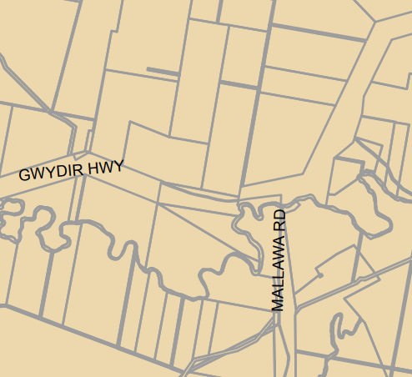
Figure 5: Land use zoning excerpt from LEP Map LNZ_004
SITE
According to the land use terms contained in the RU1 Zone (and defined in the Dictionary), the proposal satisfies the definition of ‘electricity generating works’ which is a permissible use with consent as ‘Any other development no specified in item 2 or 4’ of the Land Use Table in Clause 2.3.

Further, pursuant to Clause 2.36(b)(i) of the T&I SEPP the proposed development is permissible with consent within a prescribed zone in which the RU1 zone is identified under Clause 2.35.

The zone objectives of the RU1 zone area as follows (pursuant to the Land Use Table in Clause 2.3):

Zone RU1 Primary Production

  - To encourage sustainable primary industry production by maintaining and enhancing the natural resource base.
  - To encourage diversity in primary industry enterprises and systems appropriate for the area.
  - To minimise the fragmentation and alienation of resource lands.
  - To minimise conflict between land uses within this zone and land uses within adjoining zones.
  - To permit development for certain purposes if it can be demonstrated that suitable land or premises are not available elsewhere.
  - To protect significant agricultural resources in recognition of their value to the longer term economic sustainability of Moree Plains.
  - To maintain the rural character of the land.
The proposal is considered to be consistent with these zone objectives for the following reasons:
- The development proposal does not result in the fragmentation of agricultural land nor result in land use conflict between adjoining zones;
- The development proposal encourages sustainable energy production and diversifies the economic and commercial enterprises and employment opportunities within the municipality; and
- The rural character of the locality is not significantly compromised as a result of the development.
General Controls and Development Standards (Part 2, 4, 5 and 6)

The LEP also contains controls relating to development standards, miscellaneous provisions, and local provisions. The controls relevant to the proposal are considered in Table 4 below.
Table 4: Consideration of the LEP Controls
Control | Requirement | Proposal | Comply
Minimum subdivision Lot size  (Cl 4.1) | 100ha | The proposal does not include subdivision nor the construction of a dwelling. The MLS is not applicable for this development. | NA
Height of buildings  (Cl 4.3(2)) | Not mapped | The site is not mapped with a maximum building height restriction. The maximum height of the solar panel at full tilt is 1.047m This is considered appropriate. | NA
FSR  (Cl 4.4(2)) | Not mapped |  | NA
Land acquisition (Cl 5.1/5.1A) | Not Mapped |  | NA
Heritage  (Cl 5.10) | Not mapped | The site is not identified as being a heritage item or within a heritage conservation area. The closest heritage item to the site is located east and identified as I003 – “Comdabello Homestead”. The development proposal is not considered to impact upon the heritage item. A AHIMS search was conducted of the site with a 1km buffer. The search returned 1 Aboriginal sites or places within the search area. A further search with a 200m buffer was conducted, the search did not return any results. Given the disturbed nature of the site, it is considered unlikely that any Aboriginal objects or artefacts would be disturbed. However, should an object be unearthed during construction, all works are to cease, and the relevant authority notified. | Yes
Flood Planning (Cl 5.21) | FPL | The associated LEP Maps identify the site as being flood prone. The proposed development would be located within an existing levee. The Gwydir Floodplain Management Plan (FMP) was gazetted in 2016. The site is mapped within Management Zone C. Pursuant to Table 5 of the Rural floodplain management plans: technical manual for plans developed under the Water Management Act 2000, areas mapped as MZC are enclosed by approved flood works if they are not overtopped during large floods. Accordingly, given the current mapping and levee, the development is not considered to be impacted by flood nor will the development impact upon flood behaviour. | Y
Earthworks  (Cl 7.1) | To ensure that earthworks for which development consent is required will not have a detrimental impact on environmental functions and processes, neighbouring uses, cultural or heritage items or features of the surrounding land | The earthworks associated with the development is the installation of PV Panels. The works increase the impervious area across the site. A request for further information request was sent to the applicant. The further information received 6 January 2022 detailing that the development would utilise the existing stormwater infrastructure onsite and managed through EPA licence EPL 10832 to ensure water quality was not compromised. The management plan for the site consists of:  a) The collection and drainage of all areas onsite, including the proposed solar array, to the northwest corner of the site via an existing internal drainage network. The flat grade of the drains act as a silt trap. The deposited silt is excavated occasionally and reused onsite.  b) At the north-west corner of the site is a gated pipe to control the discharge of stormwater. This is a primary control to stop the release of contaminated water from the site. All testing occurs here.  c) The siltation pond slows the velocity of the water and allows all small particles to be deposited and removed from the water. Most sediments are removed at this location with the water sometimes not escaping the pond. This stored water is used on site for dust control on all roads.  d) Excess runoff from the siltation pond flows overland within land owned by the Proponent and is stored again temporarily at Site D. If the water level becomes high at D it is released into the irrigation channel adjacent via gated pipes and the water is sent to the Wathagar on-farm storage dam also owned by Sundown Pastoral Co. The water is later used for irrigation.  Review of the stormwater management plan was undertaken by Council’s Engineers, confirming acceptance of the submitted by SMK on 6th January 2022 (Ref:21-367) in relation to the proposed stormwater management for the proposed 4.95 MW Solar Farm.  The development does not incorporate fill. The likelihood of disturbance of relics has been addressed under Clause 5.10 | Y

The proposal is generally consistent with the LEP.

  - Section 4.15 (1)(a)(ii) - Provisions of any Proposed Instruments
There are several proposed instruments which have been the subject of public consultation under the EP&A Act, and which may be relevant to the proposal, including the following:
- Draft Remediation of Land SEPP
- Draft SEPP (Environment)
These proposed instruments have been considered. Further assessment against the draft SEPPs is not warranted with the consolidation of SEPPs occurring 1 March 2022. To this extent the above listed SEPPs are deemed not relevant to the application.

  - Section 4.15(1)(a)(iii) - Provisions of any Development Control Plan
The following Development Control Plan is relevant to this application:
- Moree Plains Development Control Plan 2013 (‘the DCP’)
  - Chapter 2 – Parking
  - Chapter 4 – Moree and Environs Floodplain Development and Management
  - Chapter 8 – Industrial Subdivision and Development
  - Chapter 9 – Rural Development.
See Attachment 7 for compliance.
The following contributions plans are relevant pursuant to Section 7.18 of the EP&A Act and have been considered in the recommended conditions (notwithstanding Contributions plans are not DCPs they are required to be considered):

- S94A Development Contributions Plan 2006 as amended on 7 January 2016
This Contributions Plan has been considered and included the recommended draft consent condition.
  - Section 4.15(1)(a)(iiia) – Planning agreements under Section 7.4 of the EP&A Act

There have been no planning agreements entered into and there are no draft planning agreements being proposed for the site.

  - Section 4.15(1)(a)(iv) - Provisions of Regulations

Clause 61 of the EP&A Regulation 2021 contains matters that must be taken into consideration by a consent authority in determining a development application, comprising the following:
Item | Provision | Assessment
61 (1) | In determining a development application for the demolition of a building, the consent authority must consider the Australian Standard AS 2601—2001: The Demolition of Structures. | N/A  The development proposal does not include demolition.
61 (2)(a) | In determining a development application for the carrying out of development on land that is subject to a subdivision order under the Act, Schedule 7, the consent authority must consider—  (a) the subdivision order, and | N/A  The development does not subject to a subdivision order.
61 (2)(b) | (b) any development plan prepared for the land by a relevant authority under that Schedule. | N/A  As above.
61 (3)(a) | In determining a development application for development on the following land, the consent authority must consider the Dark Sky Planning Guideline—  (a) land in the local government area of Coonamble, Gilgandra or Warrumbungle Shire or in the part of the local government area of Dubbo Regional that was formerly in the City of Dubbo, | N/A  The subject site is not located within a LGA listed under 61 (3)(a).
61 (3)(b) | (b) land less than 200 kilometres from the Siding Spring Observatory, if the development is—  (i) State significant development, or  (ii) designated development, or  (iii) development specified in State Environmental Planning Policy (State and Regional Development) 2011, Schedule 7. | N/A  The subject site is not located within 200km of Sliding Spring Observatory.
61 (4) | In determining a development application for development for the purposes of a manor house or multi dwelling housing (terraces), the consent authority must consider the Low Rise Housing Diversity Design Guide for Development Applications published by the Department in July 2020. | N/A  The development proposal does not relate to a manor house or multi dwelling housing (terraces).
61 (5) | Subsection (4) applies only if the consent authority is satisfied there is not a development control plan that adequately addresses the development. | N/A  As above.
61 (6) | In determining a development application for development for the erection of a building for residential purposes on land in Penrith City Centre, within the meaning of Penrith Local Environmental Plan 2010, the consent authority must consider the Development Assessment Guideline: An Adaptive Response to Flood Risk Management for Residential Development in the Penrith City Centre published by the Department on 28 June 2019. | N/A  The development application does not relate to land in Penrith City Centre.
61 (7) | In determining a development application for development on land to which Wagga Wagga Local Environmental Plan 2010 applies, the consent authority must consider whether the development is consistent with the Wagga Wagga Special Activation Precinct Master Plan published by the Department in May 2021 | N/A  The subject site is not land to which the Wagga Wagga LEP 2010 applies.
61 (8) | Subsection (7) does not apply to a development application made on or after 31 March 2022. | As above.

No draft conditions of consent are required to address Section 61 of the EP&A Regulation 2021.

  - Section 4.15(1)(b) - Likely Impacts of Development

The likely impacts of that development, including environmental impacts on both the natural and built environments, and social and economic impacts in the locality must be considered. In this regard, potential impacts related to the proposal have been considered in response to SEPPs, LEP and DCP controls outlined above and the Key Issues section below.

- Context and setting –

The development proposal is appropriate for the locality and setting, being appropriate in both size and scale for the rural locality. The Development Application has taken into consideration the rural landscape, confirming that the development is not considered to result in an adverse visual or rural character impact. Appropriate boundary offsets are provided and whilst a change to the rural landscape will occur because of the development the impact is not considered significant which requires mitigation landscaping or increased boundary offsets. The development is not considered to detract from the rural landscape and is compatible with the existing land uses. No impacts on adjoining landowners has been identified.

- Access and traffic

The primary access to the development has been revised, resulting in access from the west via main Keytah Property access from the Goonal Road and not from the Gwydir Highway. The ‘informal’ gravel access track located on-site will not be utilised by the personnel and contractors associated with construction and operation of the solar farm. An owner’s consent form for Sundown Pastoral Pty was lodged with the DA, noting that the land proposed for site access is also in this ownership, thus covers the proposed amendment. These details were provided to TfNSW for consideration, however at the time of writing this report, no response was received. Given the access no longer is proposed via the Gwydir Highway, all construction traffic including all heavy vehicle traffic would access the site from a local road, meaning that the proposal has minimal impact on the state road. Council’s Engineers are satisfied for the vehicle swept paths analysis to be a DA condition tied to the Driveway Access Application. They are of the view that there is sufficient space for road trains etc and the detailed plans will provide an accurate basis for design. It is understood a response is imminent and will be provided to the Panel prior to determination. Given the removal of access to the Classified Road, it is anticipated TfNSW will not raise any concerns.

- Public Domain

The development proposal is not identified to have an adverse impact on the public domain. The development proposal for solar electricity infrastructure does not allow for public recreation. Accordingly, there is no necessity for public or private open space to be provided as part of the project. The development is not identified to have any impact on pedestrian linkages in the area nor will it adversely impact public infrastructure. The contributions collected as part of this development application can be used to implement the Moree Plains Capital Works Projects.

- Utilities

The development proposal to construct a 4.95MW solar power farm creates energy to be connected to the grid. Referral Response from Essential Energy had no specific comments or objections to the development.

The development does not seek connection water, sewer or gas.

- Heritage

The site is not identified as being a heritage item or within a heritage conservation area. The closest heritage item to the site is located east and identified as I003 – “Comdabello Homestead”.
The development proposal is not considered to impact upon the heritage item.
A AHIMS search was conducted of the site with a 1km buffer. The search returned one Aboriginal sites or places within the search area. A further search with a 200m buffer was conducted, the search did not return any results. Given the disturbed nature of the site, it is considered unlikely that any Aboriginal objects or artefacts would be disturbed. Furthermore, Table 5 of the Rural floodplain management plans: technical manual for plans developed under the Water Management Act 2000 details that the basis of management zone C is ‘generally not cultural’. However, should an object be unearthed during construction, all works are to cease, and the relevant authority notified.

- Other land resources

The site is not within a water catchment, or within a mining or mine subsidence district. The site is located on agricultural land. The solar farm comprises an area of approximately 6.088 ha of the subject site which measures approximately 168 ha. This equates to 3.62% of the agricultural land. Whilst the proposed development will utilise 3.62% of the total potential agricultural land, this development provides a positive economic and environmental impact through:
  - Create of construction jobs and monetary input into the construction industry
  - Contribution to the electricity grid in a sustainable manner that reduces greenhouse gas emissions and will assist the transition of the economy from reliance on fossil fuels to renewable sources to decarbonise electricity production.
  - The development actively combats the impacts of climate change by providing a renewable energy source into the grid.

The proposed development is considered to have a net environmental and economic benefit whilst allowing 96.38% of the allotment to be retained for traditional agricultural purposes.

- Water/air/soils impacts

Contamination
The site is not identified as being land subject to contamination in accordance with SEPP (Resilience and Hazards). Whilst herbicides and pesticides are likely to have been used in the locality, the proposed use and ongoing maintenance is not identified to result in unreasonable contamination exposure which will risk human health. The development is not considered to increase risk of exposure. Given the cultivated land, it is unlikely that large contaminants such as asbestos are likely to present. To this extent, the site is considered fit for the intended purpose.

Water
The development increases the impervious area of the site and therefore stormwater generation and overland flows will alter as a result. Council’s Engineering Officer reviewed the submitted stormwater concept plan and considered that there were no objections. The letter submitted by SMK on 6th January 2022 (Ref:21-367) in relation to the proposed stormwater management for the proposed 4.95 MW Solar Farm was accepted.

Air quality
The construction of the proposed development is likely to generate localised air quality impacts because of additional truck movements and associated dust generation. Given the proximity to residential neighbours, the development is not anticipated to result in any adverse health impacts. After construction of the solar farm, revegetation of the site under the solar panels is proposed which will limit ongoing dust generation and associated air quality impacts.

- Flora and fauna impacts

The site area is cleared of vegetation because of ongoing farming operations. No impact to the natural biodiversity will occur during construction or operation. To this extent, no significant adverse biodiversity impacts have been identified.

- Natural environment

The topography of the site is flat with natural drainage occurring to the south and east of the site. The proposed development does not require significant earthworks to establish the development. The proposal does not result in any significant changes to the natural contours of the site.

- Noise and vibration

The potential for noise and vibration to impact on adjoining properties is a consideration through the construction of the solar farm. The closest sensitive receiver is identified as a dwelling located approximately 1.2km to the west of the site area. It is considered that the construction during normal construction times would not result in adverse noise impacts that would impact the daily lives of the occupants. Considering construction will be limited to day hours, sleep disturbance is not a factor for consideration.

Construction times will be limited to:

Monday – Friday 7am – 6pm
Saturday 8am – 1pm
No works conducted on Sunday or Public Holidays.

- Natural hazards

The site is identified to be subject to bushfire and inundation.

Bushfire
The development proposal was referred to RFS for comment. The general terms of approval are detailed within the consent. Implementing the recommended conditions will limit risk to property and life as a result of a bushfire event.

Flooding
The proposed development would be located within an existing levee approved under application 90FW833508. In accordance with the Gwydir Floodplain Management Plan (FMP), gazetted in 2016, the site is mapped within Management Zone C. Pursuant to Table 5 of the Rural floodplain management plans: technical manual for plans developed under the Water Management Act 2000, areas mapped as MZC are enclosed by approved flood works if they are not overtopped during large floods. Accordingly, given the current mapping and approved levee, the development is not considered to be impacted by flood nor will the development impact upon flood behaviour. The development is deemed suitable for the flood hazard.

- Safety, security and crime prevention

There are no associated safety, security or crime impacts associated with the proposed development. The site is securely fenced to mitigate trespass opportunities. Vegetation is limited to avoid overshadowing the solar panels during the day, accordingly, the lack of vegetation limits visually obscured areas which could encourage criminal behaviour. Given the location it is not considered that CCTV monitoring is necessary. Should vandalism or other criminal acts occur on site, CCTV can be retrospectively installed. The development is not considered to increase criminal risk to person which is not already present on the site.

- Social impact –

Perception of health and sense of place contribute to the overall social health of a community. Climate change is a ‘wicked’ global issue that results in significant angst in a range of populations. Farming communities are one of the first communities to see and feel the impacts of climate change. This is known to have a direct impact on the mental health of agricultural land owners. In recent times, the Moree Plains Local Government Area has experienced both drought and flood. The extreme environmental events have been attributed to ongoing climate change and the enhanced greenhouse effect. The proposed development for a solar power farm to contribute to renewable energy infrastructure actively seeks to combat the impacts of climate change and contribute to the global objectives of reducing carbon emissions. Indirectly, the development will have positive social impacts through the community by visually representing the combat against climate change. The development is expected to have positive environmental impacts which indirectly has a positive impact on physical and mental health.

The proposed development on the rural landscape has the potential to alter the perception of place in Moree. It is considered that the proposed development does not result in substantial visual impacts on rural landscape. The SoEE details that community consultation was conducted and visual impact on the rural landscape was a matter of community concern. Given the offset from the public domain and lack of community submissions during the exhibition period, it is concluded that the community are satisfied that the development on rural landscape is satisfactory. Thus, to this extent, the development is considered to have a low potential to adversely impact the perception of place in Moree.

The proposed development will create construction jobs and monetary expenditure within the Moree Plains LGA. This contributes to job security and in turn has positive health and social impacts for the community.

Overall, the development is considered to have a positive social impact.

- Economic impact

The proposed development is anticipated to generate 18 construction jobs for a twelve week period with one ongoing mangers position to be held for the ongoing operation and maintenance of the facility. The job generation will have a positive economic impact for local construction operators. It is anticipated that expenditure in local businesses will occur as a result. The development is considered to have positive economic impact.

- Site design and internal design

The development is considered to sited appropriately to mitigate visual impacts on the public domain. Access and traffic impacts can be suitably managed in accordance with the imposed conditions.

- Construction

Hours of construction are to occur as detailed below and under Condition D1

Monday – Friday 7am to 6pm
Saturday 8am to 1pm
No work to be conducted on Sunday or public holidays

- Cumulative impacts

The development is consistent with planning controls and no cumulative impacts have been identified during the assessment.

Accordingly, it is considered that the proposal will not result in any significant adverse impacts in the locality as outlined above.
  - Section 4.15(1)(c) - Suitability of the site

The proposed development is a suitable use of the site. The application design includes all elements required under the relevant planning instruments and policies and there are negligible anticipated adverse impacts on the locality because of the development that cannot be managed or mitigated through imposition of consent conditions. This development is permissible under the LEP and has addressed any relevant concerns. As such the site is considered suitable for the intended purpose.

  - Section 4.15(1)(d) - Public Submissions

The Application was placed on public notification for a period of twenty-one (21) days between 11 November 2021 and 2 December 2021. No public submissions were received during the notification period.

  - Section 4.15(1)(e) - Public interest

The site has access to all relevant services and the proposed development makes good use of the available land without jeopardising the agricultural viability of the land. The application design includes all elements required under the relevant planning instruments and policies and there are no anticipated negative impacts on the locality that cannot be managed or mitigated.
As detailed above, the proposed development is identified to have several positive social and economic impacts which support the proposed development. No submissions from the public were made during the exhibition period, as such it is considered that the public are not opposed to the development. As detailed above, the proposed development actively fights climate change and supports the government initiatives to reduce carbon emissions and increase renewable energy infrastructure.
To this extent, the development is in the public interest.
- REFERRALS AND SUBMISSIONS
  - Agency Referrals and Concurrence
The development application has been referred to various agencies for comment/concurrence/referral as required by the EP&A Act and outlined below in TABLE 5.
There are no outstanding issues arising from these concurrence and referral requirements subject to the imposition of the recommended conditions of consent being imposed.
Table 5: Concurrence and Referrals to agencies
Agency | Concurrence/  referral trigger | Comments  (Issue, resolution, conditions) | Resolved
Concurrence Requirements (s4.13 of EP&A Act)
Environment Agency Head (Environment, Energy & Science Group within DPIE) | S7.12(2) - Biodiversity Conservation Act 2016 | The proposal does not include vegetation removal and therefore it was concluded that there were no tangible impacts on biodiversity. Referral to the Environment Agency Head was not warranted. | NA
Rail authority for the rail corridor | Cl 86(3) - State Environmental Planning Policy (Infrastructure) 2007 | The proposal is not located in proximity to a rail corridor, thus referral to ARTC was not required. | NA
Referral/Consultation Agencies
RFS | S4.14 – EP&A Act  Development on bushfire prone land | The site is identified as bushfire prone land. Referral was made to RFS and response was received on 8 November 2021.  The referral response states the following is required:  - Fire management plan – A draft fire management plan had been prepared as Appendix 2 to the SoEE  - The development footprint shall be managed as an APZ  - A 10m defendable perimeter is to be provided around the solar array  - A minimum 20,000L water supply tank fitted with a 65mm storz fitting is to be located adjoining the internal property access within the required defendable space  - Landscaping within the APZ is to comply with Appendix 4 of Planning for Bushfire Protection 2019.  Draft conditions can be provided to address the comments made. | Y
Electricity supply authority | Cl 45 – Infrastructure SEPP  Development near electrical infrastructure | Referral to Essential Energy was made and response received. Essential Energy had no comments to make as to potential  safety risks arising from the proposed development. General comments were made in association with the development. Draft conditions are provided. | Y
Rail authority | Cl 85 – Infrastructure SEPP  Development land that is in or adjacent to a rail corridor. | As above. | NA
Transport for NSW | Cl 104 – Infrastructure SEPP  Development that is deemed to be traffic generating development in Schedule 3. | The proposal does not constitute traffic generating development pursuant to Schedule 3. | NA
Transport for NSW | Cl 18 - SEPP 64  Advertisement within 250m of classified road any part of which is visible from the classified road and subject to Cl 17. | Referral was made to TfNSW on 4 November 2021 due to the site being located adjacent to a Classified Road (Gwydir Highway). TfNSW issued a response on 21 December 2021 requesting further information due to site access being proposed to the Gwydir Highway.  Referral to TfNSW was issued on 4 November 2021 to assess the impact of the development on the safety of the classified road (Gwydir Highway). TfNSW requested further information on cumulative impacts on the intersection to determine the appropriate road turn treatment. The applicant responded to the FIR from TfNSW on 24 January 2022 to address the matters raised by TfNSW. The site access was further amended by the Applicant on 2 May 2022.  The primary access to the development has been revised, resulting in access from the west via main Keytah Property access from the Goonal Road and not from the Gwydir Highway. The ‘informal’ gravel access track located on-site will not be utilised by the personnel and contractors associated with construction and operation of the solar farm. An owner’s consent form for Sundown Pastoral Pty was lodged with the DA, noting that the land proposed for site access is also in this ownership, thus covers the proposed amendment. These details were provided to TfNSW for consideration, however at the time of writing this report, no response was received. Given the access no longer is proposed via the Gwydir Highway, all construction traffic including all heavy vehicle traffic would access the site from a local road, meaning that the proposal has minimal impact on the state road. It is understood a response is imminent and will be provided to the Panel prior to determination. Given the removal of access to the Classified Road, it is anticipated TfNSW will not raise any concerns. | Y & NA
Design Review Panel | Cl 28(2)(a) – SEPP 65  Advice of the Design Review Panel (‘DRP’) | The proposal does not incorporate development triggering the requirements of SEPP 65, thus referral to the Design Review Panel was not required. | NA
Integrated Development (S 4.46 of the EP&A Act)
RFS | S100B - Rural Fires Act 1997  bush fire safety of subdivision of land that could lawfully be used for residential or rural residential purposes or development of land for special fire protection purposes |  | NA
Natural Resources Access Regulator | S89-91 – Water Management Act 2000  water use approval, water management work approval or activity approval under Part 3 of Chapter 3 | Referral to NRAR was undertaken on 4 November 2021 due to the proximity of the development to a watercourse. Response was received from NRAR on 27 May 2022 noting that a Controlled Activity Approval is required prior to construction. A condition to this effect has been included in the consent. | Y
Transport for NSW | S138 – Roads Act 1993 for works in the road reserve. |  | NA
Heritage NSW | S58 of the Heritage Act 1977 for demolition or works etc to an item listed on State Heritage Register or with an interim heritage order. |  | NA
Natural Resources Access Regulator | S89-91 – Water Management Act 2000  water use approval, water management work approval or activity approval under Part 3 of Chapter 3 |  | NA

  - Council Referrals (internal)
The development application has been referred to various Council officers for technical review as outlined TABLE 6.
Table 6: Consideration of Council Referrals
Officer | Comments | Resolved
Engineering | Council’s Engineering Officer reviewed the submitted stormwater concept plan and considered that there were no objections. The letter submitted by SMK on 6th January 2022 (Ref:21-367) in relation to the proposed stormwater management for the proposed 4.95 MW Solar Farm was accepted. | Y
Traffic |  | NA
Building |  | NA
Health |  | NA
Waste |  | NA
Public Domain/  Assets |  | NA
Heritage |  | NA
The outstanding issues raised by Council officers are considered in the Key Issues section of this report.
  - Community Consultation
The proposal was notified in accordance with the DCP/Council’s Community Participation Plan from 11 November 2021 until 2 December 2021. The Council did not receive any submissions during the notification period. No community issues have been raised.
- KEY ISSUES
The following key issues are relevant to the assessment of this application having considered the relevant planning controls and the proposal in detail:

Visual Impact and Reflectivity
Visual Impact
The development has the potential to result in visual impact on the rural landscape. Visual impact was addressed in the SoEE under section 5.5.1. It was considered that given the lack of existing trees along Gwydir Highway and the extent of the solar array, visual impact mitigation measures should be provided. A request for further information was issued to the application in which the following response received:
The panels are partly hidden to all car traffic on the Gwydir Highway and the side profile to trucks is minimal compared to the existing buildings associated with the cotton gin on the site. The cotton gin building, and seed shed are significant when compared to the minor visual profile of the panels. The profile of the panels is below the horizon and their profile are of a similar colour to the remainder of the gin yard. We believe the solar panel array’s visual aspect is minor and should be acceptable. No additional mitigation measures are therefore considered to be required, as the existing levee, which can be considered an existing mitigation measure, would obscure all (for motorists in cars) or the majority (for truck drivers) of the proposed development from public view.
As detailed in Attachment 7 – DCP Compliance Assessment, the following is considered:
The solar array is large built form structure which alters the visual appearance of the rural landscape from natural (crops) with the occasional built structure, to an isolated area with extensive built form. Further site inspection was undertaken to determine whether Council are satisfied that the change to the rural landscape is acceptable without additional mitigation measures. Observation revealed that the visual impacts from the proposed solar farm would not be significant when viewed from the Gwydir Highway. The below photo is provided from the highway at the height of a standard SUV. The proposed solar farm would be predominately screened by the flood levee bank which is some 3m above natural ground level. Final observation is that highway users in light vehicles would not be able to view the solar farm due to the levee bank while partial views would be possible from trucks and buses.
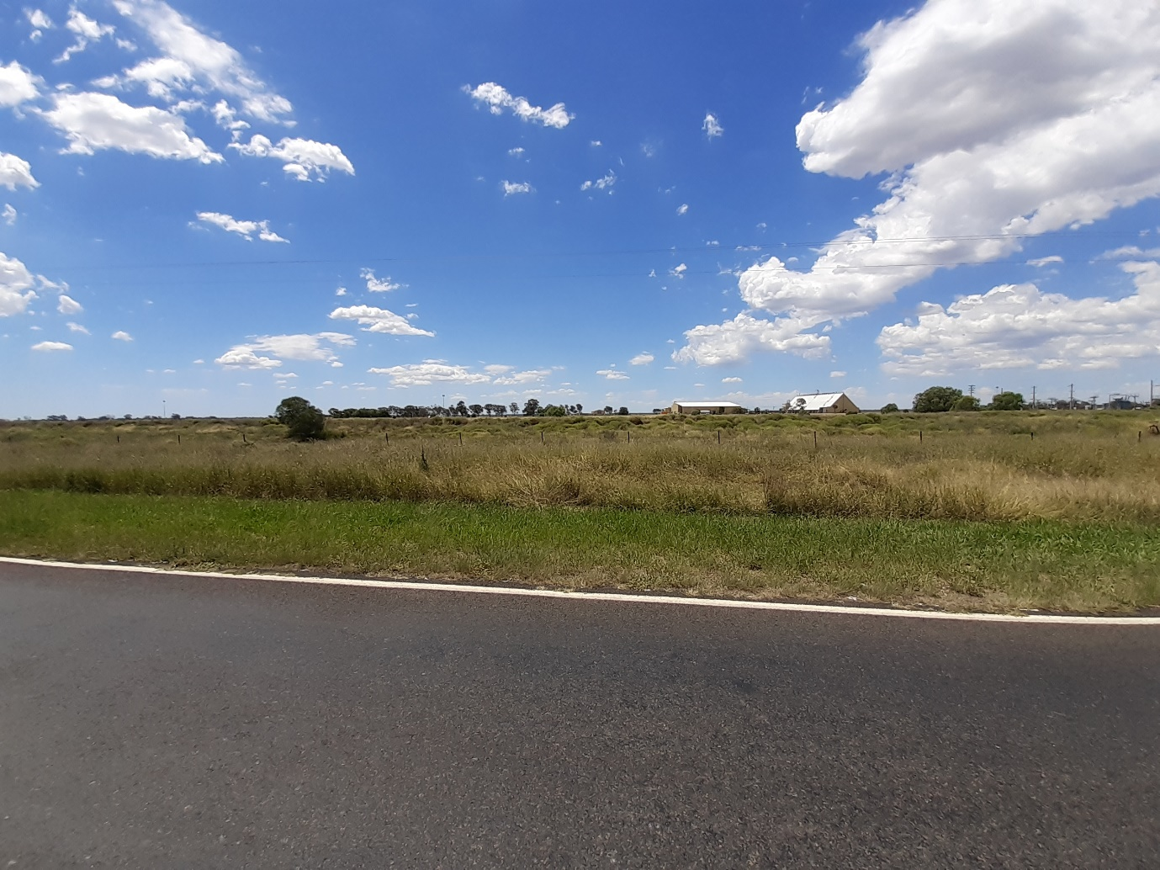
Resolution: The magnitude of change is insignificant, and thus visual impacts are acceptable.
Reflection
The development has the potential of resulting in glint and glare which could compromise the safety of the road network. The SoEE detailed that the PV Panels result in less glare and glint then many common materials and are designed to absorb 98% of light received. The response to the further information request detailed that the position of the solar array would not compromise the safety of the road network as any light reflected would be above the eyeline of both car and truck drivers. To this extent it is agreed that reflection is not an issue and the information provided is sufficient.
Resolution: No substantial glint or glare impacts have been identified which warrants mitigation measure or refusal of the application.

Flooding
The proposed development would be located within an existing levee approved under application 90FW833508. In accordance with the Gwydir Floodplain Management Plan (FMP), gazetted in 2016, the site is mapped within Management Zone C. Pursuant to Table 5 of the Rural floodplain management plans: technical manual for plans developed under the Water Management Act 2000, areas mapped as MZC are enclosed by approved flood works if they are not overtopped during large floods. Accordingly, given the current mapping and approved levee, the development is not considered to be impacted by flood nor will the development impact upon flood behaviour. The development is deemed suitable for the flood hazard.
Engineering – Traffic, Access and Stormwater
Stormwater
The works increase the impervious area across the site. A request for further information request was sent to the applicant. The further information received 6 January 2022 detailing that the development would utilise the existing stormwater infrastructure onsite and managed through EPA licence EPL 10832 to ensure water quality was not compromised. The stormwater management plan for the site consists of:
- The collection and drainage of all areas onsite, including the proposed solar array, to the northwest corner of the site via an existing internal drainage network. The flat grade of the drains act as a silt trap. The deposited silt is excavated occasionally and reused onsite.
- At the north-west corner of the site is a gated pipe to control the discharge of stormwater. This is a primary control to stop the release of contaminated water from the site. All testing occurs here.
- The siltation pond slows the velocity of the water and allows all small particles to be deposited and removed from the water. Most sediments are removed at this location with the water sometimes not escaping the pond. This stored water is used on site for dust control on all roads.
- Excess runoff from the siltation pond flows overland within land owned by the Proponent and is stored again temporarily at Site D. If the water level becomes high at D it is released into the irrigation channel adjacent via gated pipes and the water is sent to the Wathagar on-farm storage dam also owned by Sundown Pastoral Co. The water is later used for irrigation.
Resolution: Review of the stormwater management plan was completed by the engineers and confirmed to be acceptable.
Traffic and Access
The proposed access to the subject site area is via the existing entry point from Gwydir Highway. Considering the construction is anticipated to result in 1 heavy vehicle movement per day, it is considered that Gwydir Highway would have sufficient capacity and suitable sight distances to ensure safe movement to and from the subject site. On-going operation of the facility will result in 1 light vehicle movement per day for a single management / maintenance officer.
Referral to TfNSW was issued on 4 November 2021 to assess the impact of the development on the safety of the classified road (Gwydir Highway). TfNSW requested further information on cumulative impacts on the intersection to determine the appropriate road turn treatment. The applicant responded to the FIR from TfNSW on 24 January 2022 to address the matters raised by TfNSW. The site access was further amended by the Applicant on 2 May 2022.
The primary access to the development has been revised, resulting in access from the west via main Keytah Property access from the Goonal Road and not from the Gwydir Highway. The ‘informal’ gravel access track located on-site will not be utilised by the personnel and contractors associated with construction and operation of the solar farm. An owner’s consent form for Sundown Pastoral Pty was lodged with the DA, noting that the land proposed for site access is also in this ownership, thus covers the proposed amendment. These details were provided to TfNSW for consideration, however at the time of writing this report, no response was received. Given the access no longer is proposed via the Gwydir Highway, all construction traffic including all heavy vehicle traffic would access the site from a local road, meaning that the proposal has minimal impact on the state road. It is understood a response is imminent and will be provided to the Panel prior to determination. Given the removal of access to the Classified Road, it is anticipated TfNSW will not raise any concerns.
The internal access road was considered by Council Engineers to determine whether any widening is required to allow the safe movement of vehicles against the current cotton gin operations on site. Council’s Engineers are satisfied for the vehicle swept paths analysis to be a DA condition tied to the Driveway Access Application. They are of the view that there is sufficient space for road trains etc and the detailed plans will provide an accurate basis for design.
Resolution: Proceed to determination of the application subject to conditions, and following referral response from TfNSW.
Noise

The potential for noise and vibration to impact on adjoining properties is a consideration through the construction of the solar farm. The closest sensitive receiver is identified as a dwelling located approximately 1.2km to the west of the site area. It is considered that the construction during normal construction times would not result in adverse noise impacts that would impact the daily lives of the occupants. Considering construction will be limited to day hours, sleep disturbance is not a factor for consideration.

Construction times will be limited to:

Monday – Friday 7am – 6pm
Saturday 8am – 1pm
No works conducted on Sunday or Public Holidays.

Resolution: The issue can be resolved through recommended conditions of consent

Accordingly, it is considered that the proposal will not result in any significant adverse impacts in the locality as outlined above.
- CONCLUSION

This development application has been considered in accordance with the requirements of the EP&A Act and the Regulations as outlined in this report. Following a thorough assessment of the relevant planning controls, issues raised in submissions and the key issues identified in this report, it is considered that the application can be supported.

The proposed development is considered to have a positive social and economic outcome as a result of increased construction and employment opportunities. Environmental impacts identified can be managed within acceptable tolerance limits. The development is not identified to result in substantial visual, amenity or environmental impact. To this extent, the development is considered compatible with the locality and the site suitable for the proposed development.

It is considered that the key issues as outlined in Section 6 have been resolved satisfactorily through the recommended draft conditions at Attachment 8.

- RECOMMENDATION

That the Development Application DA No 2021/53 for the Erection of a 4.95MW Solar Farm at 2910 Gwydir Highway, Wathagar be APPROVED pursuant to Section 4.16(1)(a) of the Environmental Planning and Assessment Act 1979 subject to the draft conditions of consent attached to this report at Attachment 8.

